**PyBank Instructions**

In this Challenge, you are tasked with creating a Python script to analyze the financial records of your company. You will be given a financial dataset called budget_data.csv. The dataset is composed of two columns: "Date" and "Profit/Losses".

Your task is to create a Python script that analyzes the records to calculate each of the following values:

* The total number of months included in the dataset
* The net total amount of "Profit/Losses" over the entire period
* The changes in "Profit/Losses" over the entire period, and then the average of those changes
* The greatest increase in profits (date and amount) over the entire period
* The greatest decrease in profits (date and amount) over the entire period

**Screenshot of results:**

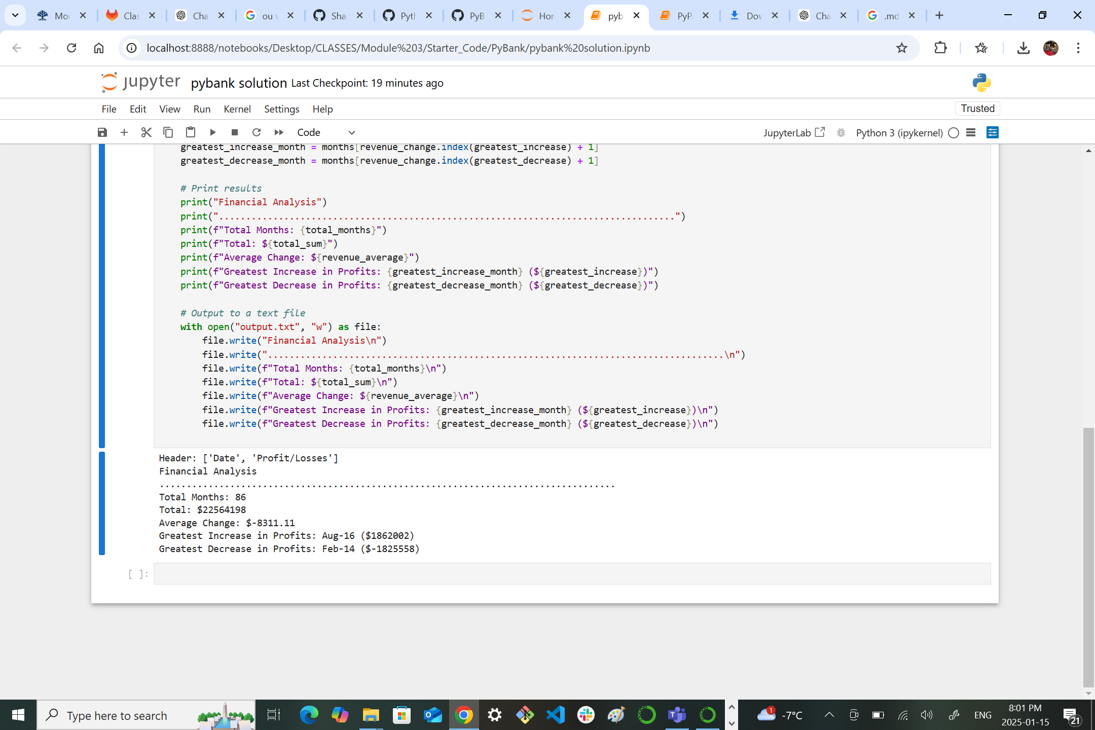

**PyPoll Instructions**

In this Challenge, you are tasked with helping a small, rural town modernize its vote-counting process.

You will be given a set of poll data called election_data.csv. The dataset is composed of three columns: "Voter ID", "County", and "Candidate". Your task is to create a Python script that analyzes the votes and calculates each of the following values:

* The total number of votes cast
* A complete list of candidates who received votes
* The percentage of votes each candidate won
* The total number of votes each candidate won
* The winner of the election based on popular vote

**Screenshot of results:**

